PREMIUM BARBERSHOP

Website & Appointment
Booking System
Project Scope, Pricing & Ongoing Costs

PROJECT DEVELOPMENT | DOMAIN & HOSTING | ONGOING MAINTENANCE
PKR 70,000 | Up to PKR 10,000* | PKR 3,000/month (optional)
Proposed first-year budget: PKR 50,000 total, assuming domain and hosting/database costs stay within the agreed PKR 10,000 allowance. Any amount above this allowance requires client approval.

Project Overview
The goal is to replace the shop’s paper-diary and phone-call appointment workflow with a simple online booking experience. Customers can choose a service, barber, date and available time. The owner can view and manage bookings from a secure dashboard.

SECTION 1 — Website & Booking System Development

One-time development fee: PKR 40,000
Recommended implementation: a cost-conscious website and booking setup. Final technology (WordPress or custom Next.js + Supabase) will be selected after confirming required features and hosting compatibility.

Customer-facing website
- Premium, mobile-responsive design for desktop, tablet and mobile.
- Home page, Services & Prices, Our Barbers, About, and Contact/Location pages.
- Barber profiles and service information provided by the client.
- Appointment form: customer name and phone, service, preferred barber, date and available time.
- Booking confirmation shown on screen; customer does not need to call to submit a booking.

Appointment management
- Owner dashboard or WordPress booking administration view for appointments.
- Filter/view bookings by date and barber.
- View customer contact details, service, appointment time and booking status.
- Owner can add walk-in bookings and update/cancel/reschedule appointments, subject to selected booking system capabilities.
- Opening hours, barber working hours and service durations configured using details supplied by the shop.
- Availability validation and protection against overlapping appointments, subject to final technical implementation.

How the system will work
- Customer opens the website — The customer reviews services, prices and barber profiles.
- Customer chooses booking details — They select a service, preferred barber, date and an available time slot.
- System checks availability — The booking system checks the selected barber’s working hours and existing appointments.
- Booking is saved — The booking is recorded in the system and shown to the owner in the dashboard/admin view.
- Owner manages appointments — The owner can review bookings and manage changes. Walk-in bookings can also be entered manually.

Included delivery items
- Initial setup, basic SEO configuration, responsive testing and production deployment.
- One handover session showing the owner how to view and manage bookings.
- Up to Four reasonable revision rounds within the agreed scope.
- Bug fixes for the delivered scope during the first 30 days after launch.

Not included in the base development fee
- WhatsApp/SMS automated notifications or reminders.
- Online payments, deposits, subscriptions or payment gateway fees.
- Customer accounts, loyalty points, advanced analytics or multi-branch management.
- Paid plugin/theme licences beyond the agreed infrastructure allowance.
- Large redesigns, new features, data entry beyond the agreed content, or ongoing maintenance.

SECTION 2 — Domain, Hosting & Website Maintenance

A. Domain, hosting and database — first-year allowance
Item | Budget allowance | Notes
Custom .com domain | PKR 8,813/- for 3 year & PKR PKR 2,844 for 1 year | Registration price varies; renewal may cost more.
Website hosting | Within remaining allowance | Choose a commercial-use-compatible plan.
Database / booking plugin | Within remaining allowance | Depends on selected architecture and plugin licence.
SSL certificate | Usually PKR 0 | Often included with hosting.
First-year domain + hosting/database allowance: up to PKR 10,000. This is a budget cap, not a guaranteed provider quote. Before purchase, the client will be shown the selected provider, upfront payment, renewal price and any licence requirements. If the required production setup exceeds this allowance, the client must approve the difference before purchase.
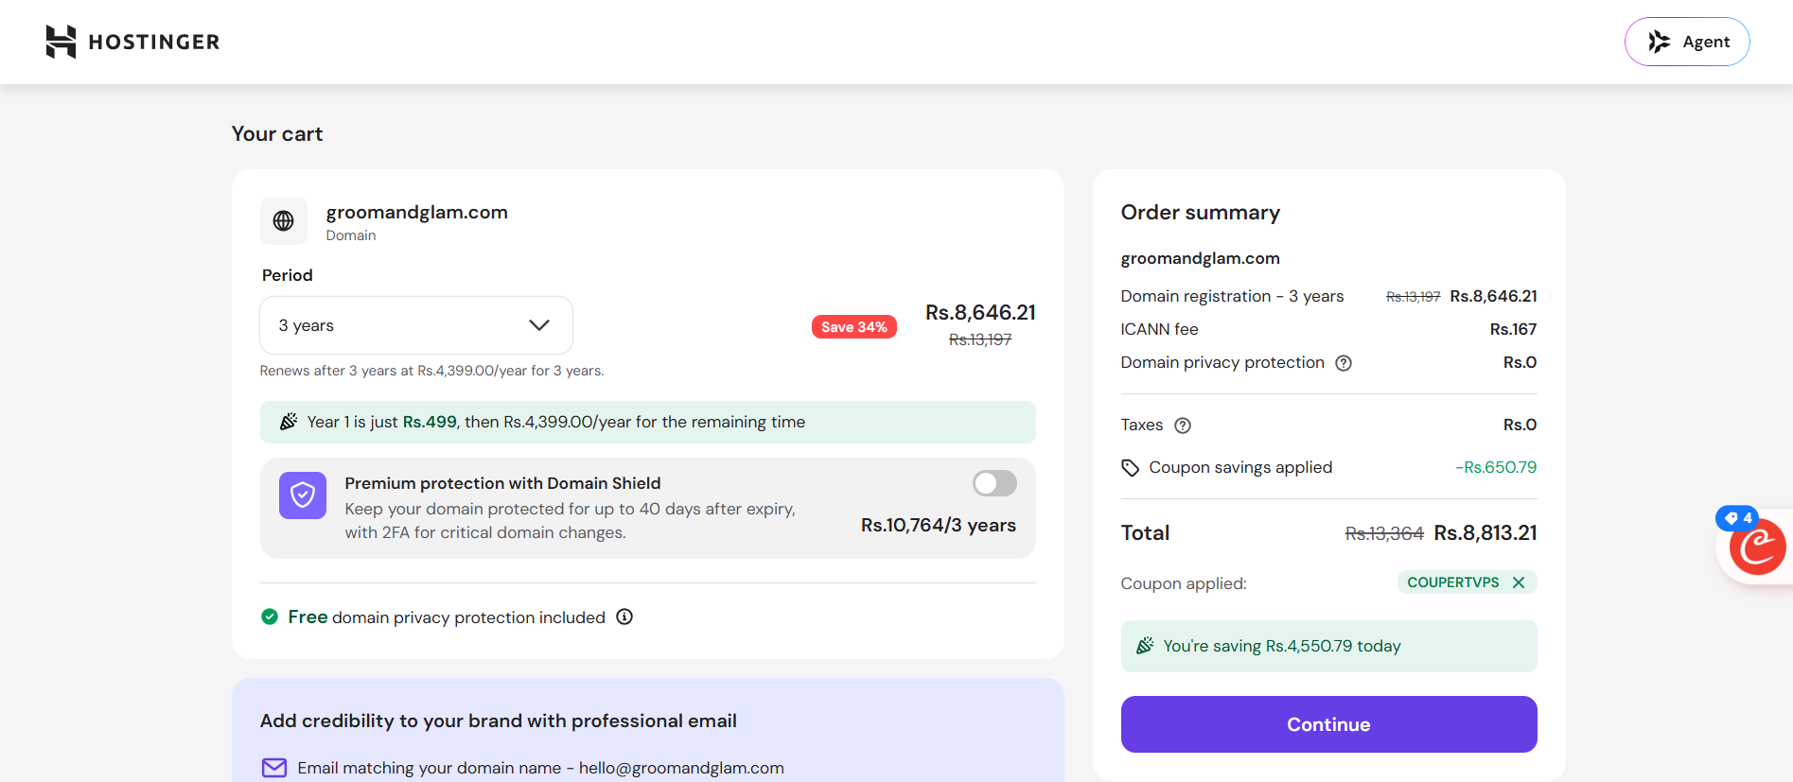

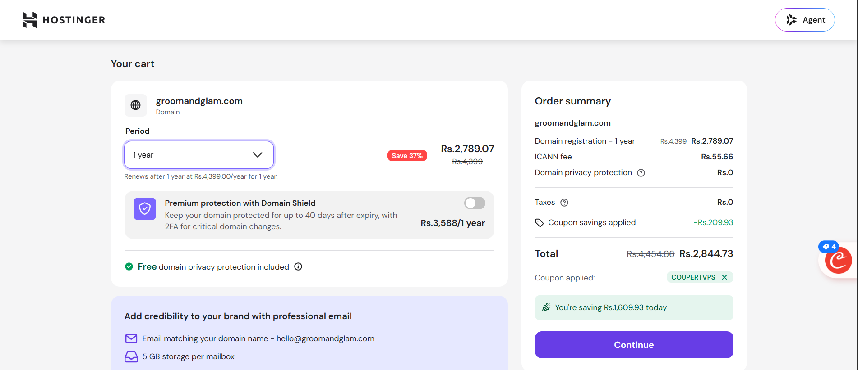

B. Ongoing maintenance — optional
Suggested basic maintenance plan: 2 Months maintenance will be free. After that, PKR 5,000 per month
- Basic website health checks and help with routine technical issues.
- Reasonable bug fixes for existing agreed features.
- Minor text or contact-detail updates, within a defined monthly limit.
- Guidance on renewals and basic backup/update checks where supported by the chosen platform.
Maintenance does not include new features, major redesigns, paid third-party subscriptions, WhatsApp/SMS usage, payment processing fees, or provider charges. These will be quoted separately.

Cost summary
Cost item | Amount | Payment timing
Website and booking system development | PKR 40,000 | One-time
Deployment + Setup + Operating Session | PKR 10,000 | Fully Deployed and Clients knows how to operate.
Domain + hosting/database allowance | Up to PKR 10,000 | First year, subject to actual provider costs.
Total proposed first-year project budget | PKR 70,000 | One-time project budget. Proposed
Basic maintenance (optional) | - 2 Months Free  - PKR 5,000/month | After launch; separate from first-year project budget
Following-year renewals | Actual renewal costs | Paid before expiry

Client responsibilities & assumptions
- Client will provide shop name/logo, service list, prices, barber names/photos, opening hours, contact details and location.
- The booking workflow and service durations will be confirmed before development starts.
- Domain and hosting accounts should be registered in the client’s name where possible; the developer can configure them.
- The final technology and provider will be selected based on confirmed needs and the budget.
- Prices are estimates in PKR and should be confirmed against provider checkout prices before purchase.
- Any work outside the agreed scope requires a separate quote and client approval.

